**Townsview School Guidance Program:**

**September Newsletter**

**Family Connection: Try This at Home**

**Have your child write and/or draw what they like about themselves – A strong self-esteem helps children have an “I CAN” attitude. By writing/drawing positive affirmations about themselves, it reinforces a growth mindset. Encourage them to place their positive reminders in a place they can see them every morning when they wake up.**

**At the end of the day, ask your child to tell you three things they can do, and one skill they can work on improving. This could be general or specific to that day. Get them to begin the sentences with “I can…” or “I can’t do ______ YET, but I will keep working hard!” For example:**

**I can listen to the teacher without interrupting.**

**I can walk peacefully in line.**

**I can write for the entire writing time.**

**I can’t recite all my math facts YET, but I will keep working hard!**

**One of the best ways you can model a growth mindset is to speak openly about the mistakes you've made, and what you've learned from them. Speak positively about your mistakes and struggles, and this will show your children that taking risks and making mistakes are a natural part of the learning process. Explain that trying hard things is what helps us grow, and you can’t be perfect when you try something hard!**

“Say This, Not That” in the link below. Hover over phrases for suggestions. (Scroll up)

[Growth Mindset For Parents | Growth Mindset Parenting (mindsetworks.com)](https://www.mindsetworks.com/parents/growth-mindset-parenting#:~:text=One%20of%20the%20best%20ways,part%20of%20the%20learning%20process.)

The read alouds below support the SEL theme of the month. You can access each read aloud on **YouTube** (click each photo to open the link).

](https://www.youtube.com/watch?v=retSVzIJmcQ) Click the pictures below to link to story read alouds [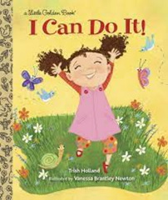](https://www.youtube.com/watch?v=PA3BouhBt-Q)[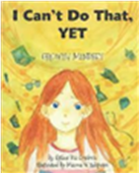](https://www.youtube.com/watch?v=NDigpsh_T8s)[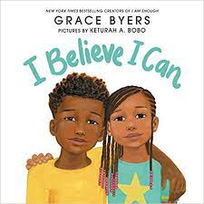](https://www.youtube.com/watch?v=p5Dsarw3ivw&t=13s)[](https://www.youtube.com/watch?v=pAg5D-vS354)[](https://www.youtube.com/watch?v=_87k2ODqoeE)

**Welcome Back!**

We are thrilled to see all the students back with us! What better way to start off than by getting ourselves in the right mindset for a fun and challenging school year. The school-wide focus for the month of September is **Growth Mindset**. Growth mindset is the belief that our skills, abilities, and talents can develop and improve over time.

The behaviour of focus for all students will be having an **“I can” attitude.** During the month of September, students will learn the importance of having a positive mindset that encourages them to keep trying in the face of adversity.

**Guidance Program**

Throughout September, guidance will support and enhance student learning through academic, social-emotional, and career development. The ESS (Guidance) teacher supports whole school initiatives (such as the Second Step and Link Program), by providing resources, activities, co-planning, co-teaching, and offering small group/individual learning opportunities related to general guidance curriculum outcomes (such as emotional regulation and friendship groups). If you have any questions about the guidance program at TVS, please feel free to contact me at the school: 506-325-4435 or [Jessica.Irvine@nbed.nb.ca](mailto:Jessica.Irvine@nbed.nb.ca).

Jessica Irvine